**Lab 02: Using Ping and Tracert**

**Task 01**

a) Ping the IP address of the Default Gateway and DNS Servers. Was the result successful?

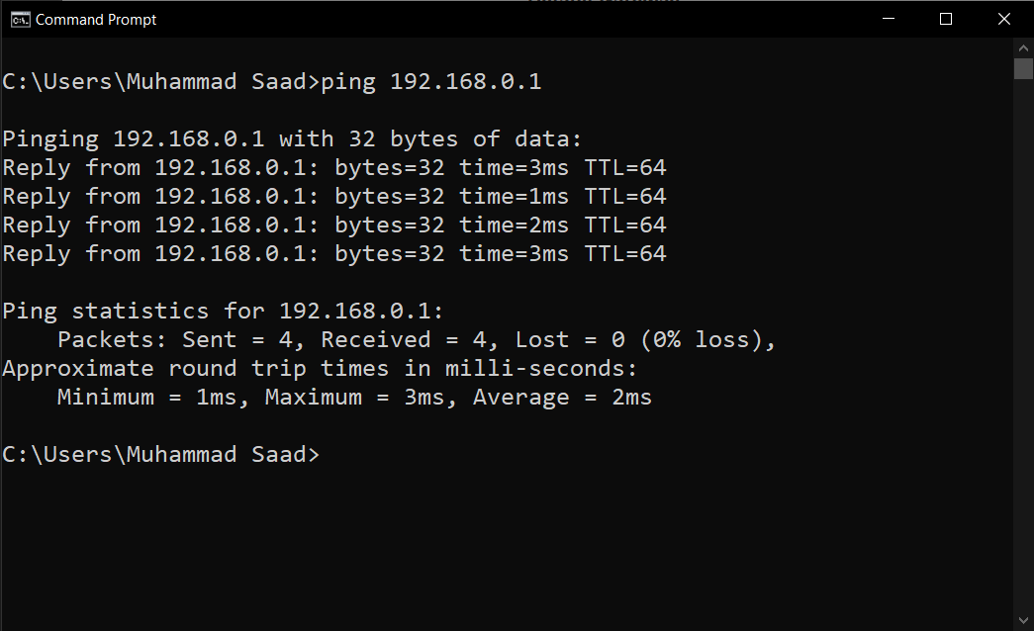

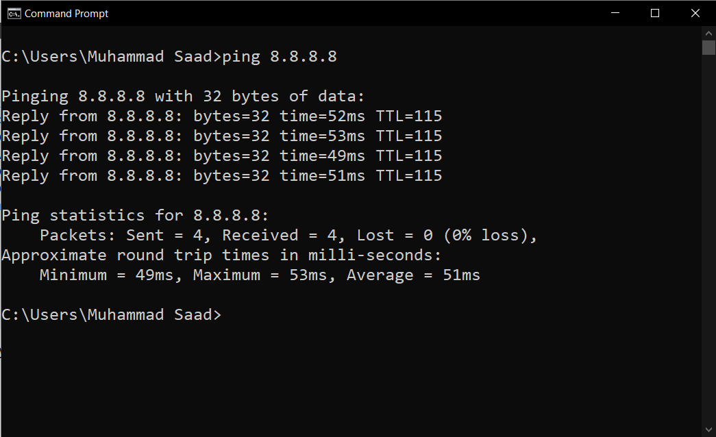

b) Ping the computer’s loop-back address. Type the following command: **>> ping 127.0.0.1**

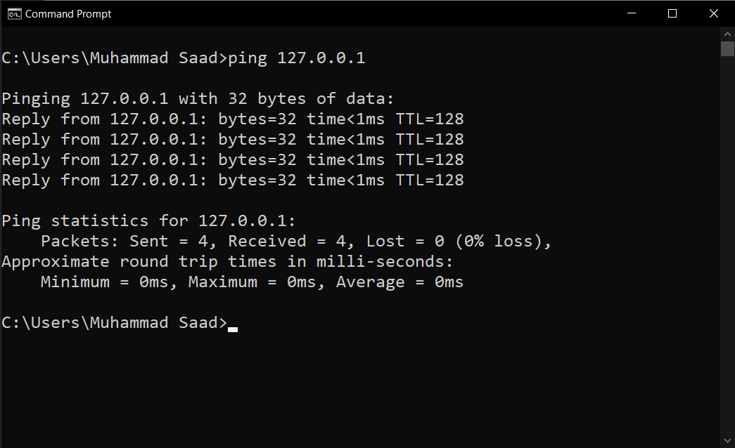

c) What is the IP Address of [www.yahoo.com](http://www.yahoo.com/):

**IP Address: 74.6.143.25**

How much time did our ping took to reach [www.yahoo.com](http://www.yahoo.com/):

**Approximate round trip times in milli-seconds:**

**Minimum = 274ms, Maximum = 347ms, Average = 325ms**

d)Ping the hostname of another computer**.** Try to ping the hostname of the computer that was recorded in the previous lab.

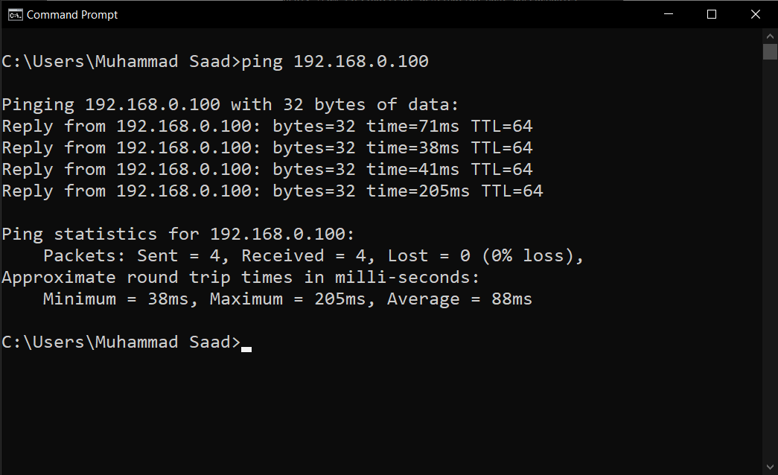

e) Ping the hostname of another computer using –t. Try to ping repetitively, the hostname of the computer.

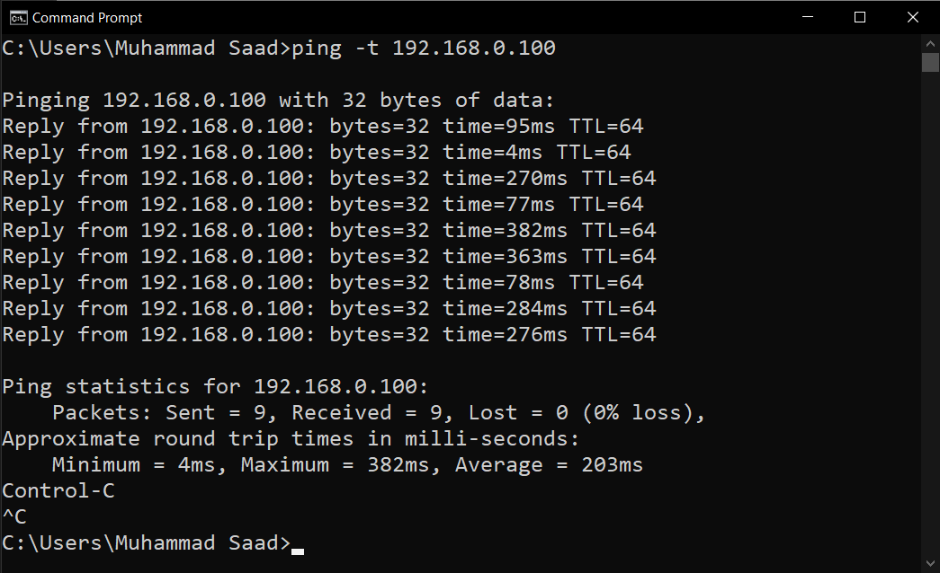

f) How can we stop the ping?

**A:** We can stop the ping by pressing **Ctrl +c**

h) ping the IP address of a DHCP or DNS server.

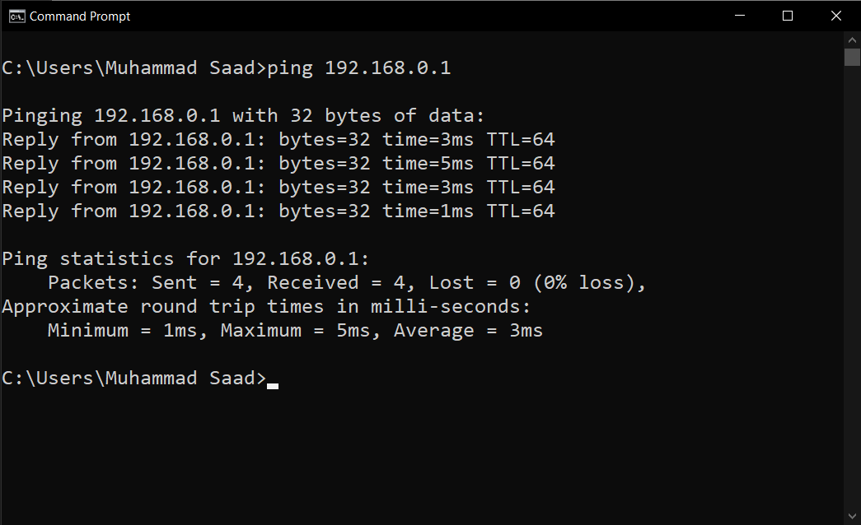

**Task 02**

1. Trace the route to the GOOGLE PAKISTAN website by typing:

**tracert** [**www.google.com.pk**](http://www.google.com.pk/)

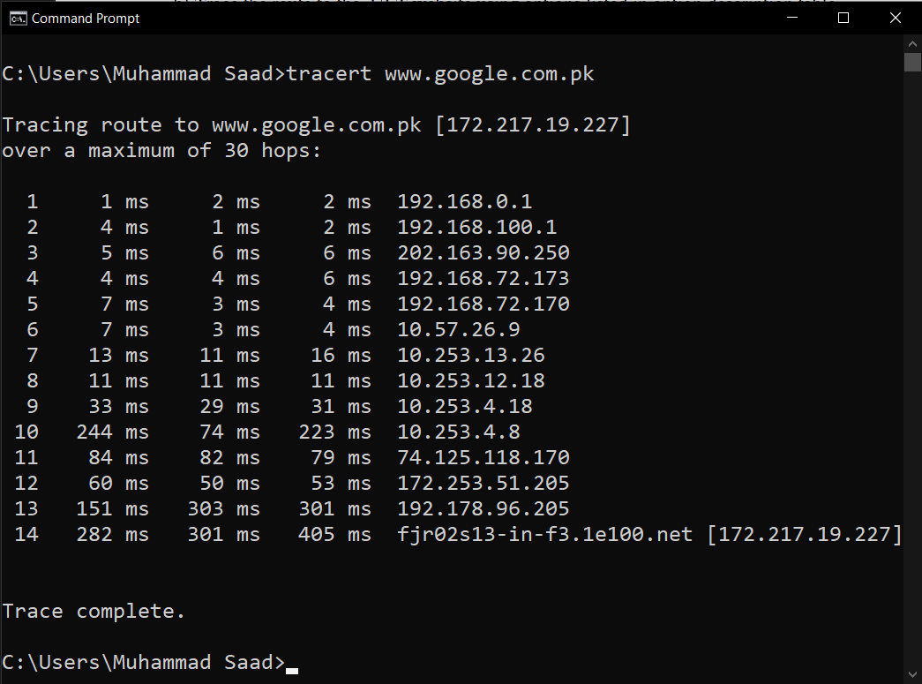

**tracert www.google.com.pk**

b) Trace the route to the UET website using options listed in option description table.

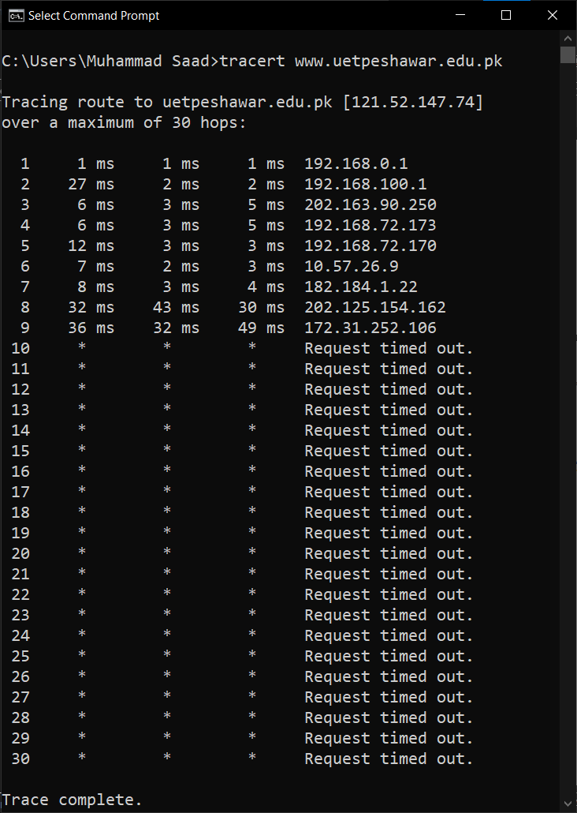**tracert www.uetpeshawar.edu.pk**

1. What is the difference between the following commands?

Tracert [www.yahoo.com](http://www.yahoo.com/)

**It will trace ‘yahoo.com’ with default 30 hop i.e 30 nodes (router, switch etc).**

Tracert –h 20 [www.yahoo.com](http://www.yahoo.com/)

**It wiil trace the IP for maximum 20 hops and may or may not reach yahoo.com.**

__________________________________________________________________________________